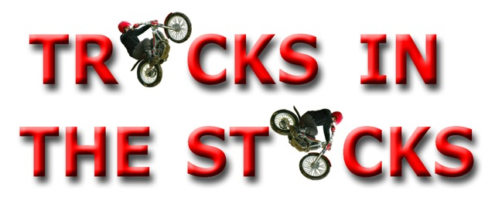

**RIDERS REGISTRATION FORM**

**RIDERS FULL NAME: D.O.B: AGE:**

**ADDRESS: OCCUPATION:**

**TELEPHONE NUMBER: EMAIL ADDRESS:**

**PAST MEDICAL HISTORY (including any known allergies)**

|  |  |  |
| --- | --- | --- |
|  | **YES** | **NO** |
| **Respiratory conditions (including asthma)** |  |  |
| **Heart Conditions** |  |  |
| **Diabetes** |  |  |
| **High/low blood pressure** |  |  |

**PLEASE LIST ANY OTHER RELEVANT MEDICAL HISTORY, INCLUDING ANY RECENT INJURIES BELOW:**

**DO YOU TAKE ANY EMERGENCY MEDICATION? (e.g., inhaler, epi-pen, insulin)**

**BIKE EXPERIENCE AND EXPECTATIONS FOR THE DAY :**

**RIDERS DECLARATION**

* **I understand the safety rules and regulations explained to me in the safety briefing, I further declare that I am at least 18 years of age, physically and mentally fit to take part in the course.**
* **I confirm that I understand the nature and type of course I am entering and its inherent risk and agree to accept the same notwithstanding that such risks may involve negligence on the part of the organiser officials**
* **I confirm that the bike I will be riding, as checked by the Instructor, is suitable and fit for purpose. I further confirm I am aware of the maximum £100 damage excess chargeable to me in the event of damage caused to the bike as a result of misuse.**
* **I understand that I must advise a staff member of any injury I may receive during the course and give permission for first aid to be carried out on me by a qualified first aider should this become necessary.**

**ACKNOWLEDGEMENT OF THE RISKS OF MOTORSPORT**

* **I understand that by taking part in motorsport I am exposing myself to a risk of death, becoming permanently disabled or suffering some other serious injury.**
* **I acknowledge that even in the event that negligence on the part of the ACU, any organiser, any landowner, or any individual who is employed by or carries out duties on behalf of any of these entities, were to be a contributory cause of any serious injury I may suffer, the dominant cause of any serious injury will always be my voluntary decision to take part in a high risk activity.**
* **I accept that insurance arranged on my behalf by the organisers of events that I may enter specifically excludes liability between the participants.**
* **I understand that this form may be used in litigation as evidence that any serious injury will be principally the result of my voluntary decision to engage in a high risk activity.**
* **I acknowledge that my participation in motorsport is entirely at my own risk**

**Riders signature ………………………………………………………………………….. Date…………………………………………**

**Form Updated 07/02/19**